

**CSE211 Web Programming, Fall Semester 24/25**

**Assignment #1: Websites Conceptual Design and Mock-up**

**Personal Information**:

**Full Name** : Ahmed Sameh Basuny

**Student ID** : 222100081

**2. Core Idea of the Assignment :**

This assignment covers the evolution of the web from Web 2.0 to Web 4.0 and explores how these advancements can be applied to design a website about movies. The objective is to create a detailed plan and design for a movie website that provides reviews, news, and information related to the film industry, using web design principles and performance and accessibility concepts.

**3. Solution to All Sections of Part 2 :**

Part 1: Research (400 words)

1. **Characteristics of Web 2.0 to Web 4.0:**

• Web 2.0: Focuses on user interaction, social networking, and user-generated content.

• Web 3.0: Enhances data and knowledge connections, allowing users to find relevant information easily through AI.

• Web 4.0: Uses advanced AI for a more personalized experience, with smart communication between devices and data.

1. **Key Features of Web 2.0 and How It Empowers Networks:**

Web 2.0 facilitates interaction between users, building communities through social media, allowing movie enthusiasts to discuss films and share opinions.

1. **Key Features of Web 3.0 and How It Enhances Data and Knowledge Connections:**

The website can use AI-powered suggestions for similar movies based on user interests, leveraging Web 3.0’s capabilities.

1. **Key Features of Web 4.0 and How It Empowers Intelligence:**

The site could employ Web 4.0 technology for an interactive, intelligent experience, such as suggesting content based on user preferences.

1. **Importance of Collective Intelligence, Social Networking, and Bookmarking:**

These technologies enable sharing of reviews and ratings, fostering a community for movie enthusiasts.

1. **How These Technologies Support Current and Future Business Plans:**

These technologies attract more visitors by promoting content sharing and social interaction.

1. **Using the Latest Technologies in Your Profession:**

These technologies can help create an interactive platform offering movie news and reviews with personalized content recommendations.

**Part 2: Website Planning**

1. **Website Purpose:**

A website dedicated to movie enthusiasts, aimed at providing reviews, news, and trailers, along with discussions about the latest releases.

1. **Goals and Target Audience:**

The goal is to build a platform for film fans to access the latest news and reviews. The target audience includes people interested in films and cinema.

1. **Opportunities and Problems:**

The site offers an opportunity to bring movie fans together in one place, addressing the lack of consolidated information on film news.

1. **Content Types:**

Includes articles, images, videos, and user reviews.

1. **Client Service:**

Offers high-quality, accessible content related to movie news.

1. **Best Method to Achieve User Goals:**

Providing a user-friendly interface for easy browsing and interaction.

**7. Finding Functions on the Site:**

Users can find films through an internal search engine, with content organized by categories.

1. **Receiving Results:**

Results will be displayed directly to the user, such as search outcomes or user comments.

1. **Handling Input:**

Respond to comments and provide immediate ratings.

1. **Follow-Up Needed:**

Keep track of user comments and ensure regular content updates.

1. **Related and Similar Sites:**

• IMDb: Offers comprehensive information on movies, including user and critic reviews.

• Rotten Tomatoes: Provides movie reviews from critics and the public.

1. **Planning Analysis Sheet:**

• Website Goal: To create a comprehensive platform for movie enthusiasts.

• Titles:

1. Homepage

2. Movie Reviews

3. Latest News

4. Movie Trailers

5. Actor Profiles

6. Forums

7. Contact Page

• Flowchart: Displays the main website page hierarchy.

**Part 3: Website Design:**

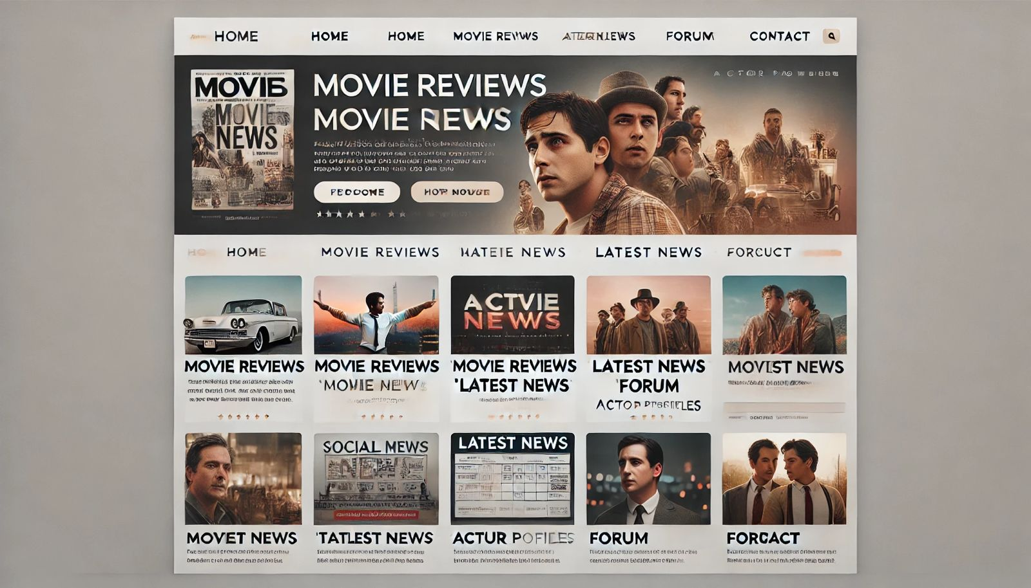

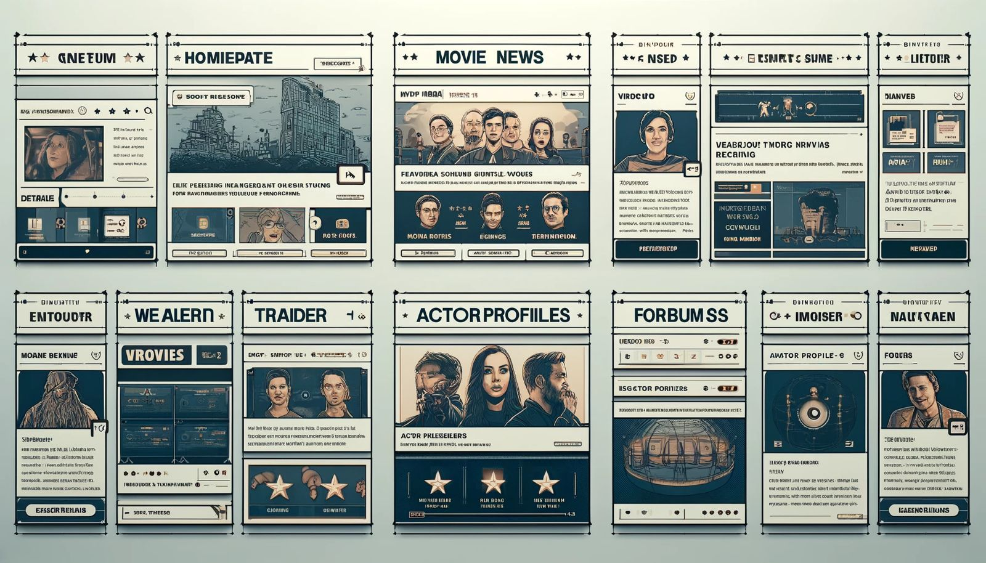

• Gestalt Web Design Principles:

• Law of Prägnanz (Good Figure): Each page will be clear and simple.

• Closure: Use elements that connect visually.

• Symmetry and Order: Present key information in an organized way.

• Figure/Ground: Separate text and backgrounds for readability.

• Uniform Connectedness: Clear visual communication between elements.

• Proximity: Use whitespace effectively to organize content.

• Additional Design Concepts:

• Screen Resolution: Design supports high-resolution screens.

• Color Palette: Select movie-themed colors.

• Contrast for Text: Ensure good contrast for readability.

• Front-End Development Technologies: Use HTML, CSS, and JavaScript.

To organize the project content and meet the requirements, here are the detailed elements for the website design and structure, page descriptions, performance indicators, and development technologies:

**1. Page Descriptions**

**Homepage**

• Content: This page introduces the site with the latest movie news and featured movie snippets. It includes a navigation menu, a “Featured Movies” section, and news updates.

• Sections:

• Navigation Bar: Contains links to other pages.

• Featured Movies: Highlights top and popular movies.

• News Section: Displays the latest movie news.

• Footer: Includes social media links and contact information.

**Movie Reviews Page:**

• Content: Contains movie reviews with ratings from users and critics.

• Sections:

• Movie List: Movies sorted by rating or genre.

• Comments Section: Allows users to leave feedback and opinions.

**Latest News Page:**

• Content: Features daily or weekly movie industry news.

• Sections:

• News Articles: Related to the cinema industry.

• Search Bar: Allows users to find specific news.

**Trailers Page:**

• Content: Showcases the latest movie trailers.

• Sections:

• Trailer List: Displays recent trailers.

• Video Player: Enables trailer playback on the page.

**Actor Profiles Page:**

• Content: Information about actors and their filmography.

• Sections:

• Profile Display: A profile for each actor with biography and notable works.

• Image Gallery: A photo gallery for each actor.

**Forums:**

• Content: A space for film enthusiasts to interact, discuss, and share opinions.

• Sections:

• Discussion Categories: Includes topics like recent movies, classic movies, etc.

• Active Topics: Shows the most active discussions.

**Contact Page :**

• Content: Provides contact details and a contact form.

• Sections:

• Contact Form: For inquiries or suggestions.

• Other Contact Info: Includes email, social media links.

**2. Website Flowchart :**

Homepage

---------------------------------------------------------

| | | |

Movie Reviews News Trailers Actor Profiles

| | |

Forum Contact Actor Profiles

**3. Wireframe for Each Page :**

You can create wireframes using tools like Adobe XD or Figma. Each wireframe should include:

• Top Navigation Bar for seamless page-to-page transition.

• Main Content Area with specific sections based on the page content (e.g., news, reviews).

• Footer with social media links and other relevant site links.

**4. Website Performance Indicators :**

To evaluate website performance, consider these indicators:

• Page Load Speed: Track how long it takes the site to load using tools like Google PageSpeed Insights.

• Visitor Count: Monitor site traffic using Google Analytics.

• Bounce Rate: Identify users who leave after viewing only one page.

• User Engagement Time: Measure how long users stay and interact with the content.

**5. Development Technologies :**

Front-End Development :

• HTML5: To structure the pages and basic elements.

• CSS3: For styling, layout, and responsive design to adapt to various screen sizes.

• JavaScript: To add interactivity, like video playback and event handling.

Content Management Systems (CMS):

• WordPress or Joomla: As a CMS to easily manage content, especially for sites with frequent updates or multiple articles.

Back-End Development :

• PHP or Node.js: To build the server and manage database interactions.

• MySQL or MongoDB: To store data such as user information and content.

• RESTful APIs: For integrating data from external sources (like trailers).

**6. Sample HTML Design for Each Page :**

Here’s a basic HTML template for the Homepage:

<!DOCTYPE html>

<html lang="en">

<head>

<meta charset="UTF-8">

<meta name="viewport" content="width=device-width, initial-scale=1.0">

<title>Movie Website - Homepage</title>

<link rel="stylesheet" href="styles.css">

</head>

<body>

<!-- Navigation Bar -->

<header>

<nav>

<ul>

<li><a href="index.html">Home</a></li>

<li><a href="reviews.html">Movie Reviews</a></li>

<li><a href="news.html">Latest News</a></li>

<li><a href="trailers.html">Trailers</a></li>

<li><a href="actors.html">Actor Profiles</a></li>

<li><a href="forum.html">Forum</a></li>

<li><a href="contact.html">Contact</a></li>

</ul>

</nav>

</header>

<!-- Featured Section -->

<section id="featured">

<h2>Featured Movies</h2>

<div class="movie">

<img src="movie1.jpg" alt="Movie 1">

<p>Latest and popular movies</p>

</div>

</section>

<!-- News Section -->

<section id="news">

<h2>Latest News</h2>

<article>

<h3>News Title 1</h3>

<p>Short description of the news...</p>

</article>

<article>

<h3>News Title 2</h3>

<p>Short description of the news...</p>

</article>

</section>

<!-- Footer -->

<footer>

<p>&copy; 2024 Movie Website</p>

<div class="social">

<a href="#">Facebook</a>

<a href="#">Twitter</a>

<a href="#">Instagram</a>

</div>

</footer>

</body>

</html>

Repeat similar HTML structures for each specific page while adjusting content sections accordingly.

This approach ensures an organized layout with the content needed for a comprehensive movie site.

4. **Conclusion :**

Creating a specialized movie website attracts cinema enthusiasts and provides them with a place to discuss the latest news and reviews.